Meadows Nursery School

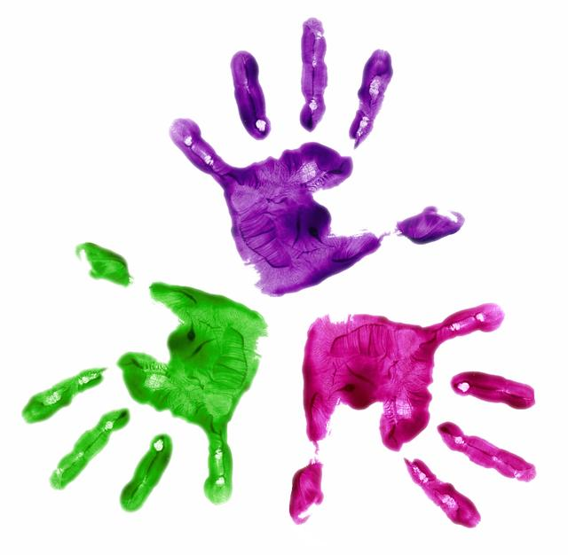
The Early Years Foundation Stage

What is it? What does it mean?

At the meadows nursery school we work alongside the Early Years Foundation Stage Framework, creating a safe, secure and happy environment through learning, playing and exploring.

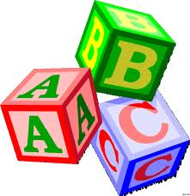

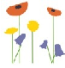 | ‘Every day a good day’
 | Meadows Nursery School EYFS Guide

What is the Early Years Foundation Stage?

At Meadows Nursery School we follow a structure of learning and care for children from birth to five years. This is called the Early Years Foundation Stage (EYFS).
The Early Years Foundation stage was made statutory from September 2008 to ensure nursery schools create a safe, secure and happy environment where they can play and develop. It was felt that at the heart of the EYFS is the principle that young children need to play in order to have fun, make friends and to begin to learn and understand about the world around them and here at the Meadows this is what we aim to do.

We provide appropriate play and learning experiences for the children’s stages of development and this is underpinned by the skills they need to work towards in the Early Years Foundation Stage, called ‘Early Learning Goals.’ We focus on 7 areas of learning and development, 3 are known as the ‘prime areas’ of learning, which underpin all aspects of learning:

- Communication and Language
- Personal, social and emotional development
- Physical Development

The other 4 areas of learning are known as the ‘specific areas’ and these are:

- Literacy
- Mathematics
- Understanding the World
- Expressive Arts and Design

At the Meadows we plan the children’s daily experiences across all 7 areas of learning and development through a number of different play environments. This planning can be seen displayed in the entrance of all nurseries and it refers to these areas of development.

We have provided this guide to outline the areas of learning and development, suggesting some ideas of what you can do at home to help your child.



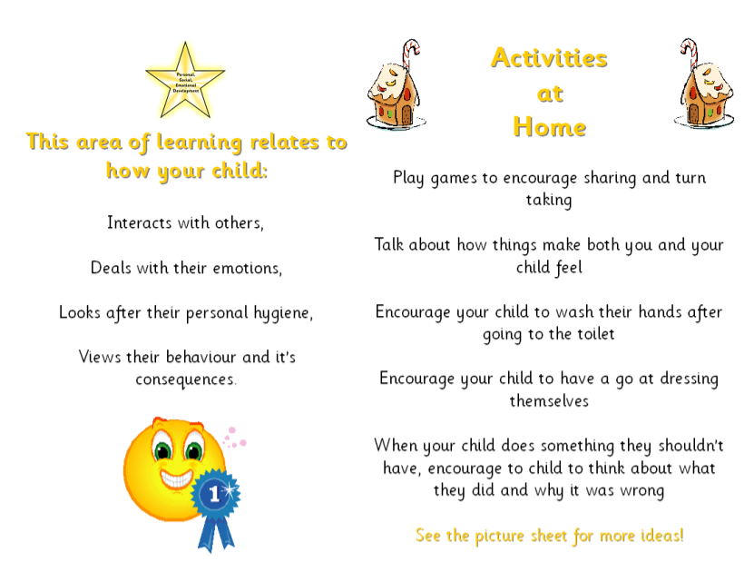
Personal, Social and Emotional Development

How does this area of learning relate to your child?  How they interact with others  How they deal with their emotions  How they look after their personal hygiene  How they view their behaviour and the consequences |  | Activities to do at home  Play games to encourage sharing and taking turns  Talk about how things make both you and your child feel  Encourage your child to wash their hands after going to the toilet  Encourage your child to have a go at dressing themselves  When your child does something they shouldn’t have, encourage your child to think about what they did and why it was wrong.

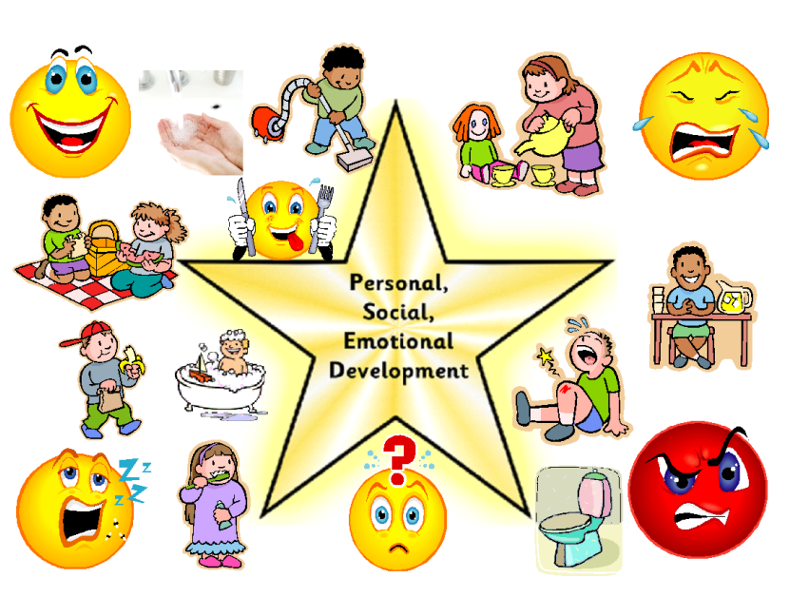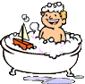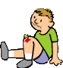
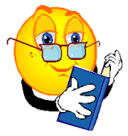
Communication and Language

How does this area of learning relate to your child?  Talks and listens to others  Enjoys learning new words, sounds and expressions  Learns letter sounds to enable them to read by decoding texts  Shows the ability to remain focused through becoming engrossed in play  Responds to requests, questions and instructions |  | Activities to do at home  Chat, talk, speak to, whisper, sing with your child  Practice sounding out words and the letters that form words.  Spend time in the garden, sitting on a bench at the bus stop or lying on your grass in the garden, listening to and talking about sounds heard.  Play Simon Says to develop listening skills.

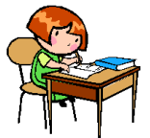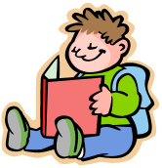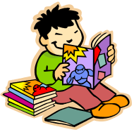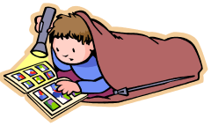

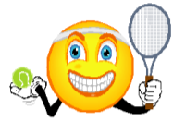
Physical Development

How does this area of learning relate to your child?  Moves using large scale movements: running, jumping and climbing.  Manipulates objects using small scale movements: cutting, drawing and threading.  They look after their own health and hygiene.  Handles toys and equipment safely and sensibly |  | Activities to do at home  Play ball games  Take a trip to the park so your child can run, climb and jump.  Talk about how your body feels after running and jumping, i.e. hot and sweaty  Make some play dough so they can explore its texture, reshape it and create models from their own ideas.  Take a pot of water and a paintbrush outside so your child can ‘paint’ the pavement, fence or shed.
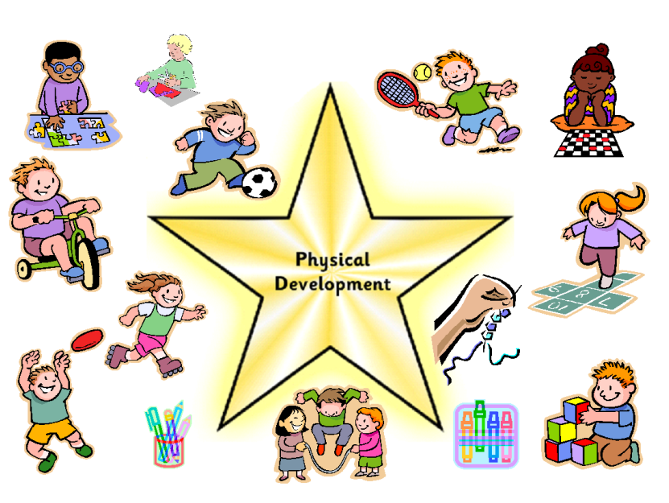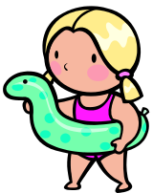
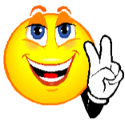
Mathematics

How does this area of learning relate to your child?  Solves problems using their own ideas and by working with others  Singing number rhymes and counting (in 1’s, 2’s and 5’s)  Exploring patterns and shapes |  | Activities to do at home  Play board games to practice counting  After doing the clothes washing, make a game out of sorting the socks.  Talk about patterns you see on clothes or on pictures.  Put lots of items in a box and then try and sort them into different piles, i.e. those that are the same colour.  Ask your child when you have a problem e.g. I have one apple and we both would like some, what shall I do?  Sing some number rhymes e.g. 1,2,3,4,5 once I caught a fish alive

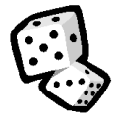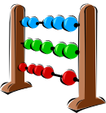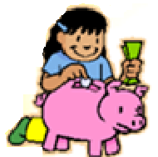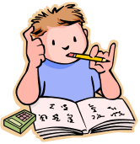

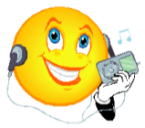
Understanding the World

How does this area of learning relate to your child?  Explores the world around them  Uses computers, phones, calculators, TV’s, Stereos and other electrical equipment  Enjoys and participates in festivals relating to their own and other cultures. |  | Activities to do at home  Talk to your child about your family, culture, religion and where you live  Talk about what you see, hear, smell, taste and touch  Ask your child what buttons they think you should press and why when using electrical equipment  Look at similarities and differences when walking or on the bus or train

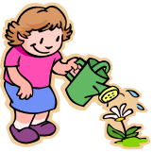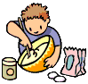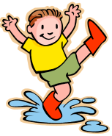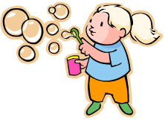

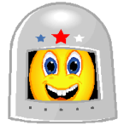
Expressive Arts and Design

How does this area of learning relate to your child?  Enjoys messy activities, exploring what happens  Pretends and role plays things they have seen and experienced  Participates in musical and dance activities  Talks about models they have made and the reasons behind different parts of the model |  | Activities to do at home  Let your child help you when you are tidying up  Be prepared for your child to become Mr, Miss or Mrs in a game of teachers. Or maybe you’ll become a passenger on your child’s train, bus or aeroplane.  Make some shakers using pots and some dried pasta or lentils.  Use your boxes to make a model – you’ll be surprised what you child will turn it into!  Keep your old clothes, shoes, hats, gloves to make an exciting box of dressing up clothes.
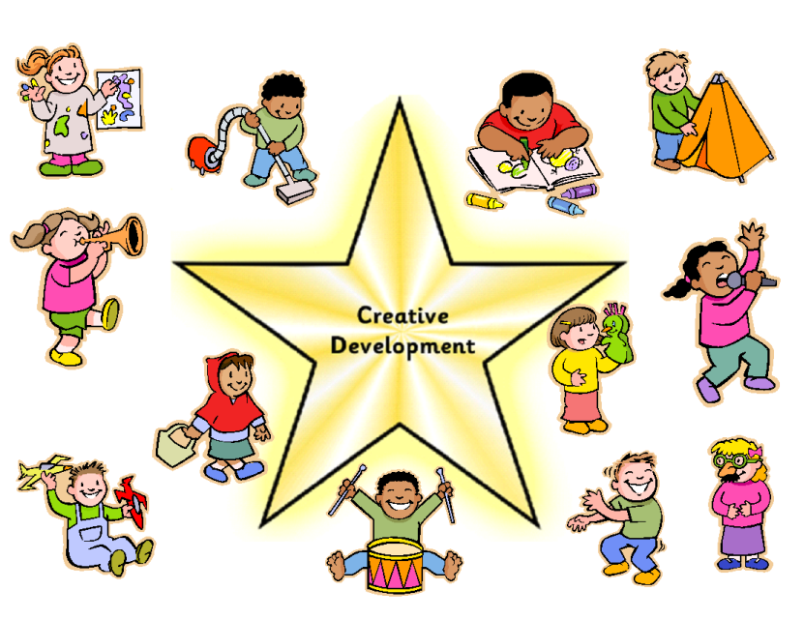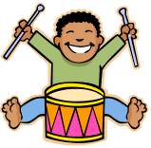
Literacy

How does this area of learning relate to your child?  Explores books  Makes up stories and retells them  Enjoys rhymes  Gives meaning to marks and enjoys mark making |  | Activities to do at home  Enjoying making up stories using their imagination or from the use of props.  Act out the story for others in your family to watch  Set up a puppet theme using a sheet and some chairs and act out a scene from your child’s favourite story.  Enjoy making marks with different media, i.e. chalks, pencils, crayons or water on walls/patio – can they talk about the marks they have made?  Points words/letters out when out and about, i.e. every time you walk past a road sign.

